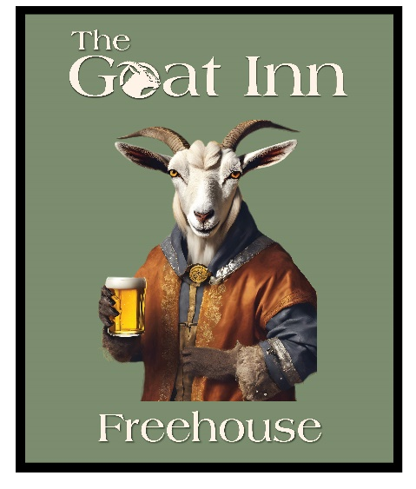

Sunday Roast Menu

Roast Topside of Beef £17.95 (kids £10.95)
Roast Leg of Pork £14.95 (kids £8.95)
Roast Crown of Turkey £14.95 (kids £8.95)
Homemade Vegetarian Nut Roast £14.95 (kids £8.95)

Honey Roasted Gammon £15.95 (when available) (kids £9.95)
Roast leg of Lamb £18.95 (when available) (kids £11.95)

All served with roast potatoes, Yorkshire Pudding, Stuffing, Seasonal Vegetables and gravy

Go Large for extra £2.50
Extra slice of meat, 2 roasties and Yorkshire pudding

Please inform us if you have any dietary needs or allergies

We run this menu alongside our full menu

