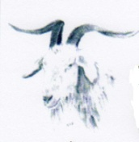
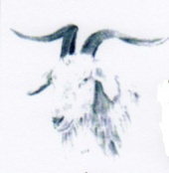
THE GOAT INN

SUNDAY ROAST DINNER SPECIAL

Roast Topside of Beef
Leg of Pork Roast
Roast crown of Turkey
Vegetarian Nut Roast with leek & mushroom sauce or vegetarian gravy
Local Great Hautbois Lamb (when available + £1.00 Supplement)
Honey Roasted Gammon ( when available)
All served with Yorkshire pudding, roast potatoes, seasonal veg and gravy

2 Course for only £14.95 per person
Two course deal includes roast and a selected dessert only- please see waiting staff for desserts available. (Excludes kid roasts)
(1 Course for £11.95)
Why not go large and get a roast for £2.50 extra and get an extra slice of meat, Yorkshire pudding and extra potatoes (excluding nut roast)

*******************************************************

Kiddie 1 course for only £6.95

Roast Topside of Beef
Leg of Pork Roast
Roast crown of Turkey
Local Great Hautbois Lamb (when available + £1.00 Supplement)
Honey Roasted Gammon (when available)
All served with Yorkshire pudding, roast potato, seasonal veg and gravy

Roast Desserts available for £4.95 for those who have not had a roast dinner

