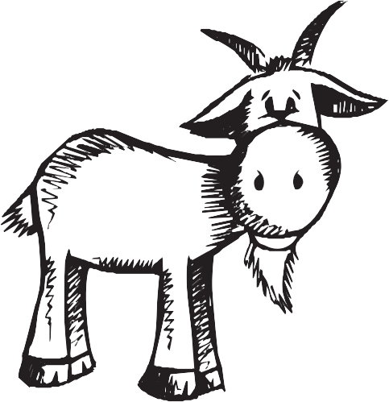

Kiddies Menu

Battered cod

Scampi

Chicken nuggets

Pizza

Fish Fingers

All served with chips, french fries or new potatoes and salad, peas or baked beans

Sausage, mash and gravy

All children’s meals £5.75

