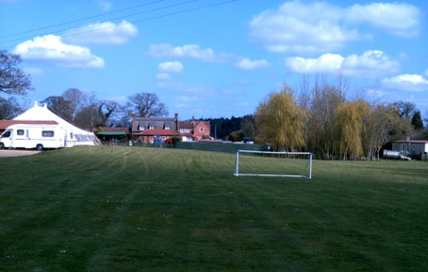Arriving and Departing

We would prefer that you arrive on site during the pub opening hours as this is where you need to book in. Not only will you receive information about the site, but you can obtain shower tokens, book in for an evening meal if you wish and we can answer any queries you may have.

It would be helpful if you could aim for a departure time by midday.

.Prices

THESE PRICES ARE BASED ON 2 ADULTS and 2 CHILDREN (under 16):

An extra person is £3 Per Night

A dog is £2 Per Night

**Tents**

£12 per night - No electricity available.

**Caravans/Motor homes etc..**

30th Sept 2016 – 31st March 2017 £15 P.N

1st April 2017 – 29th Sept 2017 £15 P.N

Marquee Hire

* Our on site Marquee is available for hire for large gatherings, weddings and other functions. Contact The Goat for further information.

**Visit Our Website : www. Skeytongoatinn.co.uk**

**or email us : Goatinn@btconnect.com**

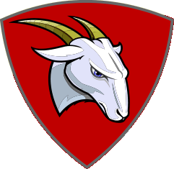

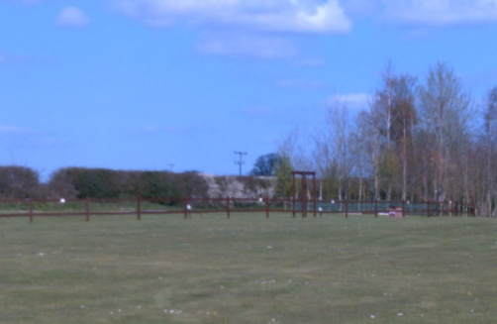

5 Caravan Pitches

Available

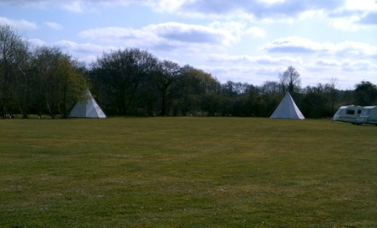

20 Tent Pitches Available

We are a small friendly site and have room for 5 caravans all within reach of electric hook up and 20 tents at any time. The site has 7 acres of grass surrounded by trees for you to enjoy the peaceful countryside. The children have plenty of room to play and run around.

There is an on site shower block facility with toilets and showers available for campers. (Shower tokens are available from the pub during opening times only). It has a wash up area and an outside tap for drinking water.

Dogs are allowed on site, but we ask that they are kept on a lead and any mess is cleared up.

**We are a Camping and Caravan Club site and would need your membership number upon booking.**

**We are able to offer you membership on arrival.**

Pub opening times

Monday - Friday: 12pm - 2pm & 6pm - 11pm

(Summer) Friday, Saturday & Sunday: 12pm – 11pm

(Winter) Saturday: 12pm – 2pm & 6pm – close

Sunday: 12pm – close

The Goat Inn Restaurant

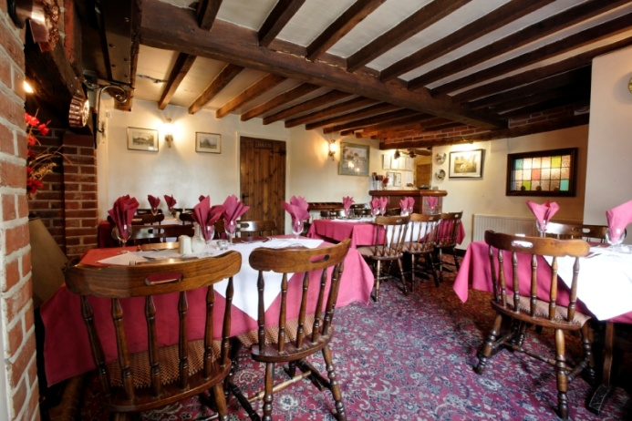

We are a family run establishment with very pleasant staff and a team of chefs in the kitchen who produce local, homemade, cooked to order, fresh delicious food. You are welcome to come in and enjoy a meal with us, either at lunch time or in the evening. Our service times are between 12 -2pm and then again at 6:30pm - 9pm every day. Or if you just fancy popping in for drink and/or to relax in our spacious beer garden, you are more than welcome.

If you fancy cooking for yourselves we have a communal BBQ for all to use, you just need to bring along the charcoal to cook your food on.

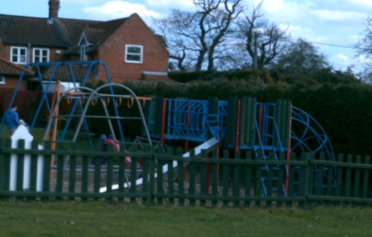We are children friendly and whilst relaxing in pleasant 7 acres of garden the children have a play area to keep amused on in the pub garden.

Near by Attractions & things to do..

We are very close to the Norfolk Broads and the beach is only 6 – 8 miles from us. There are a few fishing lakes around us within a couple of miles. For the children there is Wroxham barns and Bewilderwood, which are exciting days out, weather permitting. The lovely market towns of Aylsham and North Walsham are within a 5 mile radius, offering plenty of shopping opportunity. The small village of Wroxham is on the Norfolk Broads and contains a shop for everyone! Broads Tours in Wroxham offer day boat hire as well as informative boat trips. Coltishall village is approximately 2 miles away on the river Bure. Being situated in a very rural area of Norfolk with plenty of nice walks around, it is easy to wear the dog out and even the children!